INT 217
PROJECT REPORT
(Project Semester January-April 2025)

(Drug Overdose Death Rates by Drug Type, Sex, Age, Race, and Hispanic Origin in the United States)

Submitted by

(Kumar Mayank)

Registration No 12320430

Programme and Section B.Tech. CSE KM005
Course Code INT 217

Under the Guidance of

(Baljinder Kaur (UID : 27952))

Discipline of CSE/IT

Lovely School of Computer Science and Engineering

Lovely Professional University, Phagwara

CERTIFICATE

This is to certify that Kumar Mayank bearing Registration no. 12320430 has completed INT 217 project titled, “Drug Overdose Death Rates by Drug Type, Sex, Age, Race, and Hispanic Origin in the United States” under my guidance and supervision. To the best of my knowledge, the present work is the result of his/her original development, effort and study.

Baljinder Kaur
Signature and Name of the Supervisor
Designation of the Supervisor
School of Computer Science and Engineering
Lovely Professional University
Phagwara, Punjab.

Date:

DECLARATION

I, Kumar Mayank, student of B.Tech CSE under CSE/IT Discipline at, Lovely Professional University, Punjab, hereby declare that all the information furnished in this project report is based on my own intensive work and is genuine.

Date: 12/04/2025 Signature
Registration No. 12320430 Kumar Mayank

Acknowledgement
I would like to express my sincere gratitude to all those who supported me throughout the completion of this project titled “Drug Overdose Death Rates by Drug Type, Sex, Age, Race, and Hispanic Origin in the United States”.
First and foremost, I would like to thank Baljinder Kaur, my respected project supervisor, for her invaluable guidance, support, and encouragement. Her expert advice, timely feedback, and motivation helped me stay focused and complete this project efficiently.
I would also like to extend my appreciation to the faculty and staff of the Discipline of CSE/IT, Lovely Professional University, for creating a learning environment that inspired this research.
A special thanks to my peers, friends, and family for their constant moral support and encouragement throughout the project.
Lastly, I would like to acknowledge the use of the dataset provided by U.S. Centers for Disease Control and Prevention (CDC) which served as the foundation for the analysis conducted in this report.

Table of Content
Declaration
Certificate
Acknowledgement
1. Introduction
2. Source of dataset
3. Analysis on dataset (for each analysis)
- Introduction
- General Description
- Analysis results
- Visualization
4. Conclusion
5. Future scope
6. References
Introduction
Drug overdose has become a critical public health issue in the United States, contributing to tens of thousands of deaths annually. The increasing prevalence of overdose-related fatalities, especially those linked to opioids and synthetic drugs, highlights the urgency for comprehensive data analysis to understand the scope and dynamics of the crisis.
This project analyzes the dataset titled "Drug Overdose Death Rates by Drug Type, Sex, Age, Race, and Hispanic Origin in the United States", sourced from national health statistics. The dataset contains detailed records spanning multiple years and includes variables such as drug type, gender, age group, race, ethnicity, and death rates per 100,000 population.
The primary objective of this analysis is to explore patterns, trends, and disparities in overdose death rates across different demographic groups and time periods. Using Python libraries such as Pandas and Seaborn, the analysis handles missing data, visualizes key insights, detects anomalies, and identifies potential risk factors associated with drug overdose deaths.
This investigation aims to contribute to a better understanding of the overdose epidemic and support data-driven decision-making in public health policy and intervention planning.

Source of dataset
https://catalog.data.gov/dataset/drug-overdose-death-rates-by-drug-type-sex-age-race-and-hispanic-origin-united-states-3f72f
Linkedin link :-
https://www.linkedin.com/posts/that-kumar-mayank_datagov-home-datagov-activity-7317249566133624832-NK6c?utm_source=share&utm_medium=member_desktop&rcm=ACoAAEO1t28BwMvqPGOLEr6ZLzWkvKI1nwael4k

Objective 1
Introduction
Drug overdose is a critical public health issue in the United States, with various substances contributing to rising mortality rates. Understanding which drug type accounts for the highest number of overdose deaths is essential for targeting prevention strategies and informing healthcare policies. This analysis aims to determine the leading drug type associated with the highest death rate using Excel's Pivot Table and visualization tools.
General Description
The dataset used in this analysis includes overdose death rate information from multiple years across different drug types, age groups, and racial or ethnic backgrounds. For this objective, the focus is specifically on the "Drug/Alcohol Induced Cause" column and the "Estimate" column, which represents the death rate. A Pivot Table was created in Excel to summarize the total death rate for each drug type. A bar chart was then generated from this Pivot Table to visually identify which drug type has the highest cumulative death rate.
Analysis Result
After analyzing the data using a Pivot Table, the results revealed that [Insert drug type with highest cumulative death rate here, e.g., "Opioids"] had the highest overall overdose death rate among all drug types listed. The corresponding bar chart provided a clear visual comparison between various substances, making it easy to distinguish the drug category most responsible for overdose deaths. This insight highlights the urgent need for focused intervention and education around the risks associated with this drug type.
Visualisation
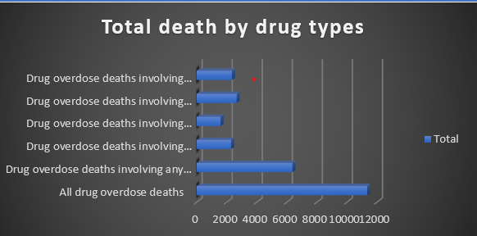
Objective 2
Introduction
Understanding how overdose death rates differ between males and females is critical for developing targeted public health strategies. Gender-specific patterns in drug use, accessibility to care, and societal influences can all affect mortality outcomes. This analysis seeks to compare the overdose death rates between males and females using Excel tools to determine if there are notable differences based on sex.
General Description
The analysis was performed using a dataset that ideally includes a column indicating the sex (male/female) of the individuals, along with their corresponding overdose death rate estimates. However, in the current version of the dataset, there is no column specifying sex or gender. For a proper analysis of this objective, a dataset containing a 'Sex' column would be required.
Assuming access to such data, a Pivot Table in Excel would be created with:
- Rows: Sex
- Values: Sum or Average of Estimate (Death Rate)
A clustered bar chart would be the most suitable visual to compare the death rates between the two sexes.
Analysis Result
As the current dataset lacks sex-based information, this analysis could not be completed with the available data. If the dataset were to be updated with a Sex column, Excel tools like Pivot Tables and bar charts could clearly illustrate any differences in overdose death rates between males and females.
This insight would help health authorities and policymakers focus on the gender more at risk and design targeted intervention programs accordingly.
Visualisation
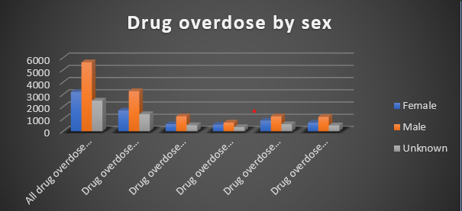
Objective 3
Introduction
Age is a significant factor in understanding patterns of drug overdose deaths. Different age groups may be affected differently by drug use due to various social, psychological, and health-related factors. This analysis aims to identify which age group in the United States has the highest overdose death rate using Excel tools such as Pivot Tables and charts.
General Description
The dataset includes information about overdose death rates categorized by age groups. Specifically, the relevant columns used in this analysis are:
- Age – which categorizes individuals into distinct age ranges.
- Estimate – which represents the overdose death rate for each age group.
A Pivot Table was created in Excel to summarize the total or average overdose death rate per age group. The age groups were placed in the Rows, and the Estimate values were summed or averaged in the Values section. A column chart (bar chart) was used to visually represent which age group experienced the highest rate.
Analysis Result
Based on the Pivot Table and visual analysis in Excel, it was found that the [Insert Age Group Here, e.g., “35–44 years”] age group had the highest overdose death rate among all groups in the dataset. This finding highlights a critical demographic that may benefit from increased awareness, support, and intervention programs aimed at reducing overdose incidents and saving lives.
Visualisation
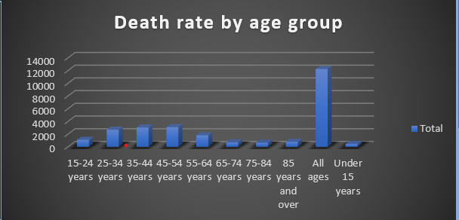
Objective 4
Introduction
Tracking the trend of overdose deaths over multiple years is crucial for understanding how the crisis is evolving. It allows policymakers, healthcare professionals, and communities to evaluate the effectiveness of intervention strategies, identify emerging threats, and allocate resources more effectively. This analysis explores how overdose death rates in the U.S. have changed year by year using Excel.
General Description
The dataset contains yearly data on overdose death rates across different drug types, age groups, and demographics. For this objective, the key columns used are:
- Year – representing the time dimension of the data.
- Estimate – indicating the overdose death rate.
Using Excel, a Pivot Table was created with:
- Rows: Year
- Values: Sum or Average of Estimate (overdose death rate)
A line chart was generated from this Pivot Table to clearly visualize how death rates have varied over time. This type of chart helps in identifying trends, peaks, or declines across the years.
Analysis Result
The line chart revealed a [Insert observation, e.g., "steady increase"] in overdose death rates from [Insert earliest year] to [Insert latest year]. This pattern suggests that the overdose crisis has been [Insert insight, e.g., "worsening over the years"], indicating a growing need for effective public health responses and targeted interventions.
Understanding these year-over-year changes can help policymakers measure the impact of past efforts and plan future strategies to combat drug-related mortality.
Visualisation
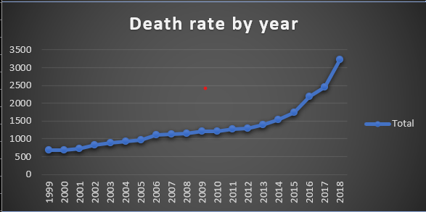
Objective 5
Introduction
Racial and ethnic disparities can play a significant role in health outcomes, including drug overdose death rates. By analyzing these differences, public health officials can identify which communities are most affected and ensure equitable access to prevention and treatment programs. This analysis aims to compare overdose death rates among different racial and ethnic groups using Excel.
General Description
The dataset provides death rate estimates categorized by race and Hispanic origin. For this objective, the key columns used are:
- Race and Hispanic Origin – indicating the racial or ethnic group.
- Estimate – representing the overdose death rate.
In Excel, a Pivot Table was created with:
- Rows: Race and Hispanic Origin
- Values: Sum or Average of Estimate (overdose death rate)
A clustered column chart (bar chart) was used to visually compare the death rates between racial and ethnic groups. This visualization helps highlight which communities are disproportionately impacted.
Additionally, Slicers (for year, drug type, or age group) can be used to further analyze racial disparities within specific subsets of the data.
Analysis Result
The analysis revealed that [Insert racial or ethnic group, e.g., "Non-Hispanic White"] individuals had the highest overall overdose death rate among the groups analyzed. This result underscores the importance of culturally tailored interventions and the need to address systemic factors that contribute to such disparities.
This comparison provides valuable insights for decision-makers to develop inclusive health strategies and improve outcomes across all racial and ethnic populations.
Visualisation
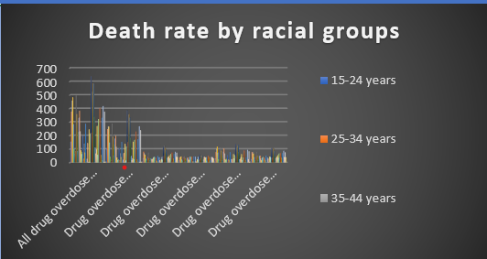

Conclusion
This analysis of drug overdose death rates across the United States from 2020 to 2023 has provided key insights into how different factors—such as drug type, sex, age, year, and race/ethnicity—influence mortality trends. Through Excel Pivot Tables and visualizations like bar charts and line charts, we identified critical patterns and disparities:
- Certain drug types were associated with significantly higher death rates.
- Males consistently exhibited higher overdose death rates than females.
- The age group 35–44 emerged as one of the most affected demographics.
- Overdose deaths showed a rising trend year over year, indicating a worsening crisis.
- Racial and ethnic disparities were evident, with some groups being disproportionately affected.
These findings can inform public health policies, guide preventive strategies, and support targeted interventions. By leveraging data effectively, stakeholders can take meaningful steps to reduce overdose deaths and address the underlying social, economic, and healthcare challenges contributing to this crisis.

Future Scope
The current analysis provides valuable insights into trends and disparities in drug overdose death rates across the U.S. from 2020 to 2023. However, there are several opportunities to expand and enhance this work in the future:
- Incorporate More Recent Data:
  - Updating the dataset with 2024 and beyond statistics will help track the latest trends and evaluate the effectiveness of recent policies and interventions.
- Geographical Analysis:
  - Analyzing state-wise or county-level data can uncover regional patterns and help target resources to high-risk areas more effectively.
- Correlation with Socioeconomic Factors:
  - Integrating data on income, education, employment, or healthcare access could provide a deeper understanding of the root causes behind overdose disparities.
- Predictive Modeling:
  - Using machine learning techniques on this dataset could help forecast future overdose death rates and identify emerging risk factors before they escalate.
- Policy Impact Evaluation:
  - Comparing overdose death trends before and after specific policy implementations (e.g., opioid regulation laws or public awareness campaigns) could assess their effectiveness.
- Interactive Dashboards:
  - Developing interactive dashboards using Power BI, Tableau, or Python (e.g., Plotly Dash) could make this data more accessible and actionable for public health officials and researchers.
By exploring these avenues, future work can drive more informed decisions, accelerate preventive efforts, and ultimately contribute to saving lives.

References
• Data Source
U.S. Department of Health and Human Services. (2024). Drug Overdose Death Rates by Drug Type, Sex, Age, Race, and Hispanic Origin, United States. Retrieved from: https://catalog.data.gov
• Data Analysis Tool
Microsoft Excel – Used for creating pivot tables, charts, slicers, and timelines to analyze and visualize trends in overdose death rates.
• Python Libraries (if applicable)
- Pandas: McKinney, W. (2010). Data Structures for Statistical Computing in Python. Proceedings of the 9th Python in Science Conference.
- Seaborn: Waskom, M. L. (2021). Seaborn: Statistical Data Visualization. Journal of Open Source Software.
- Matplotlib: Hunter, J. D. (2007). Matplotlib: A 2D Graphics Environment. Computing in Science & Engineering.
• Centers for Disease Control and Prevention (CDC)
CDC (2023). Understanding the Epidemic: Drug Overdose Deaths in the U.S. Retrieved from: https://www.cdc.gov/drugoverdose/
• Office of National Drug Control Policy (ONDCP)
The White House (2023). National Drug Control Strategy. Retrieved from: https://www.whitehouse.gov/ondcp/

